SRI8610C Gas Chromatograph START Procedure

1. Check the water level (1A) of the SRI Model H2-100 Hydrogen Generator. If near Low, fill with Distilled Water (Only!) via the top fill cap (1B) to near the High Line.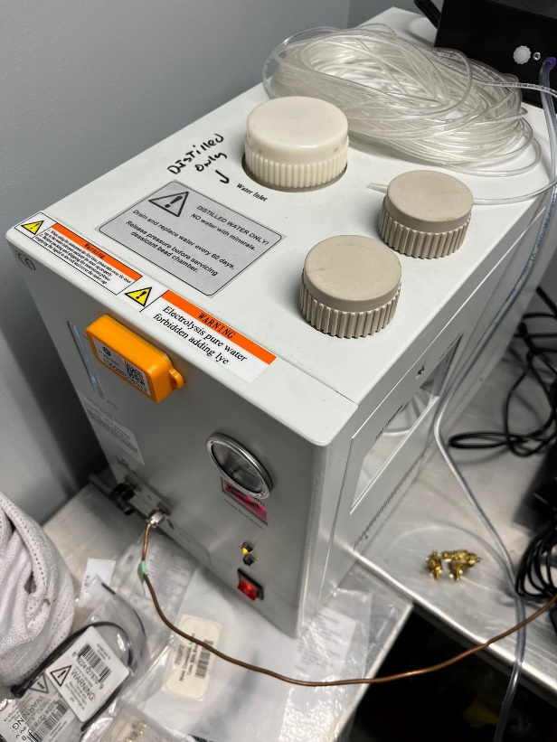

**2B**

**1B**

**1A**

1. 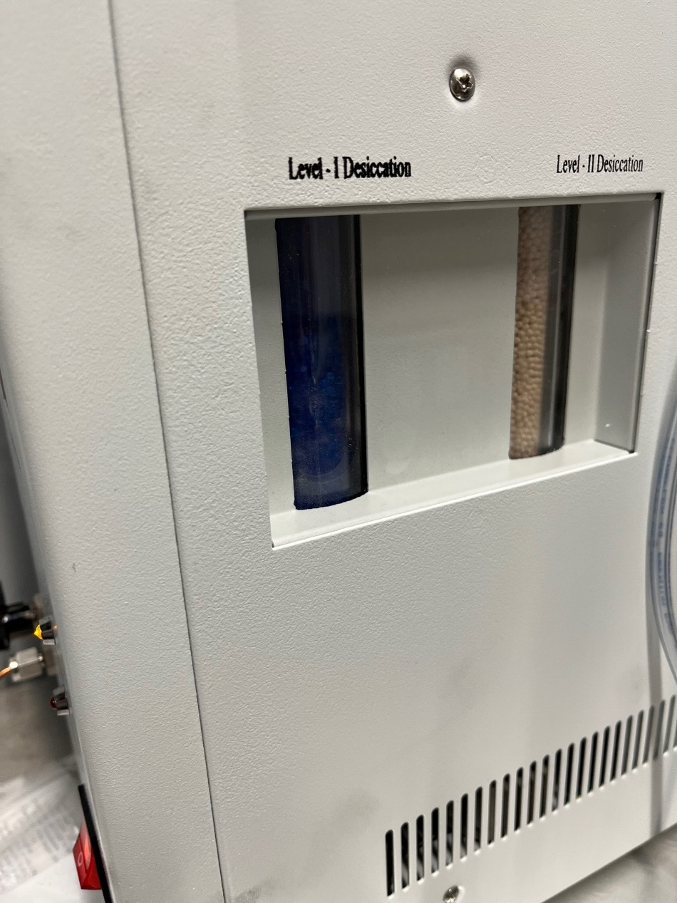Check the state of the desiccant hydrogen dryer (2A) in the SRI Model H2-100 Hydrogen Generator. If this desiccant is Blue, it is fine, and you can continue. If it is Pink, then you need to regenerate it before continuing.

**2A**

* 1. Unscrew the lid (2B) and remove the desiccant container (2C next page).
  2. Open the desiccant container (2D next page) and pour the desiccant into a glass or ceramic microwave safe container (2E next page). Regenerating the desiccant makes it hot.
  3. Microwave the desiccant for 5 minutes (per equipment supplier). Desiccant and container will be HOT after regeneration.
  4. Allow desiccant to cool before replacing in the plastic container to prevent damage.
  5. Replace the desiccant container and screw the cap back on (2B). This needs to be very tight to prevent H2 leakage.

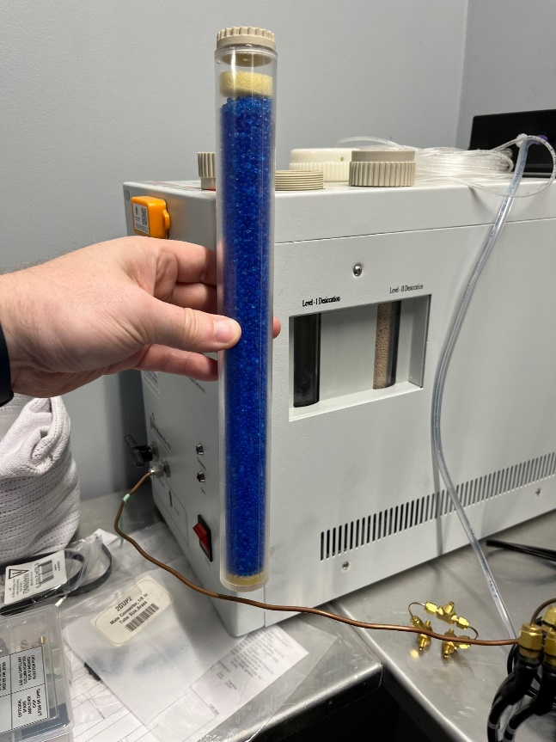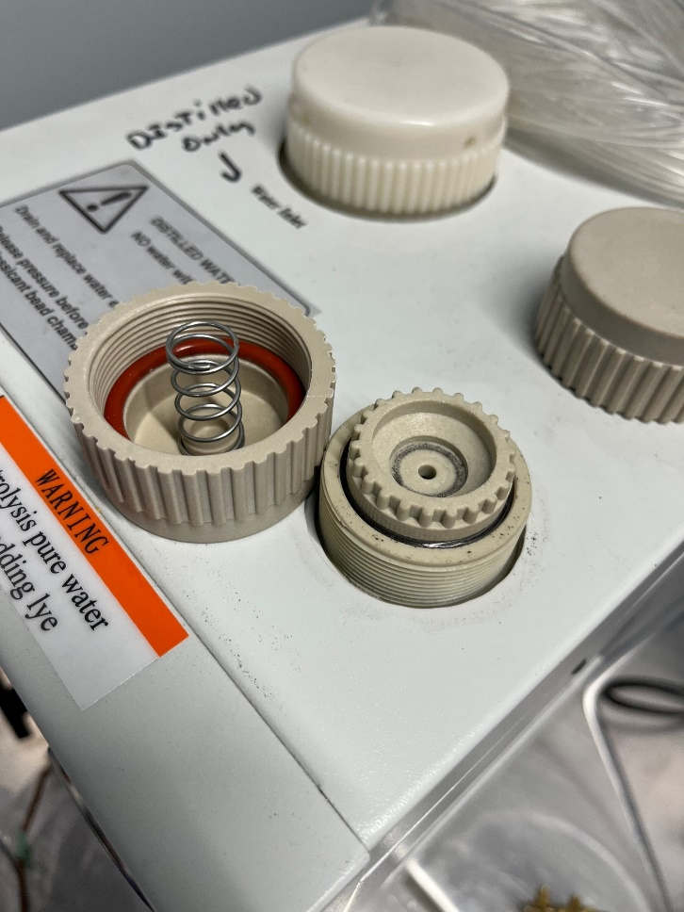jk

**2C**

**2C**

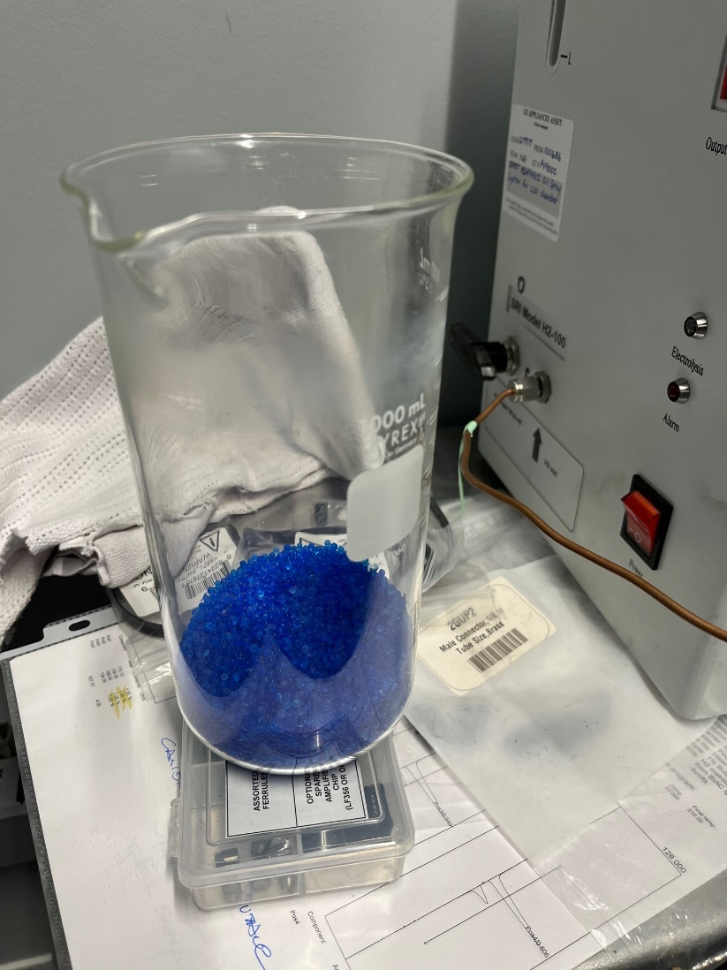

**2E**

**2D**

1. 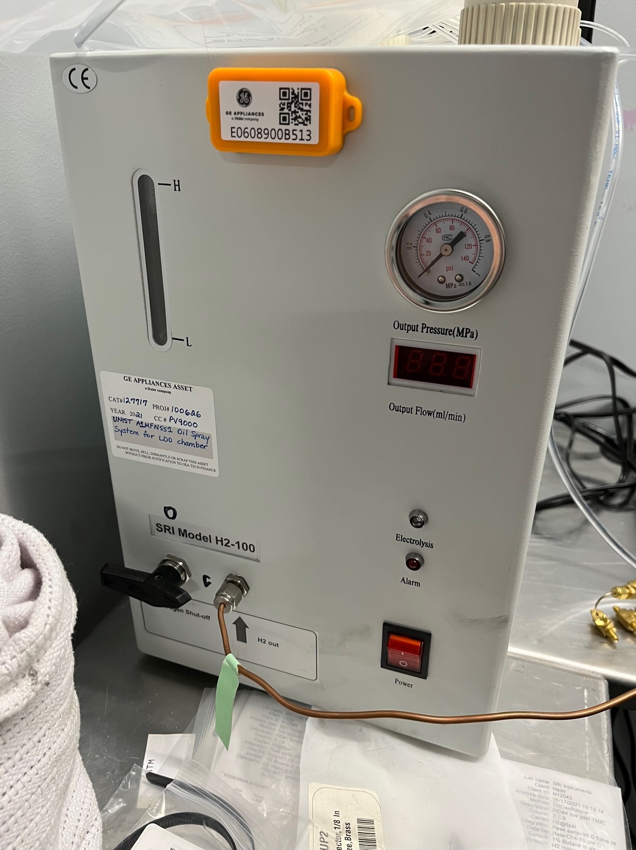Verify the H2 output valve on the SRI Model H2-100 Hydrogen Generator is closed (3A).
2. Switch the SRI Model H2-100 Hydrogen Generator on (4A).

**4A**

**3A**

1. 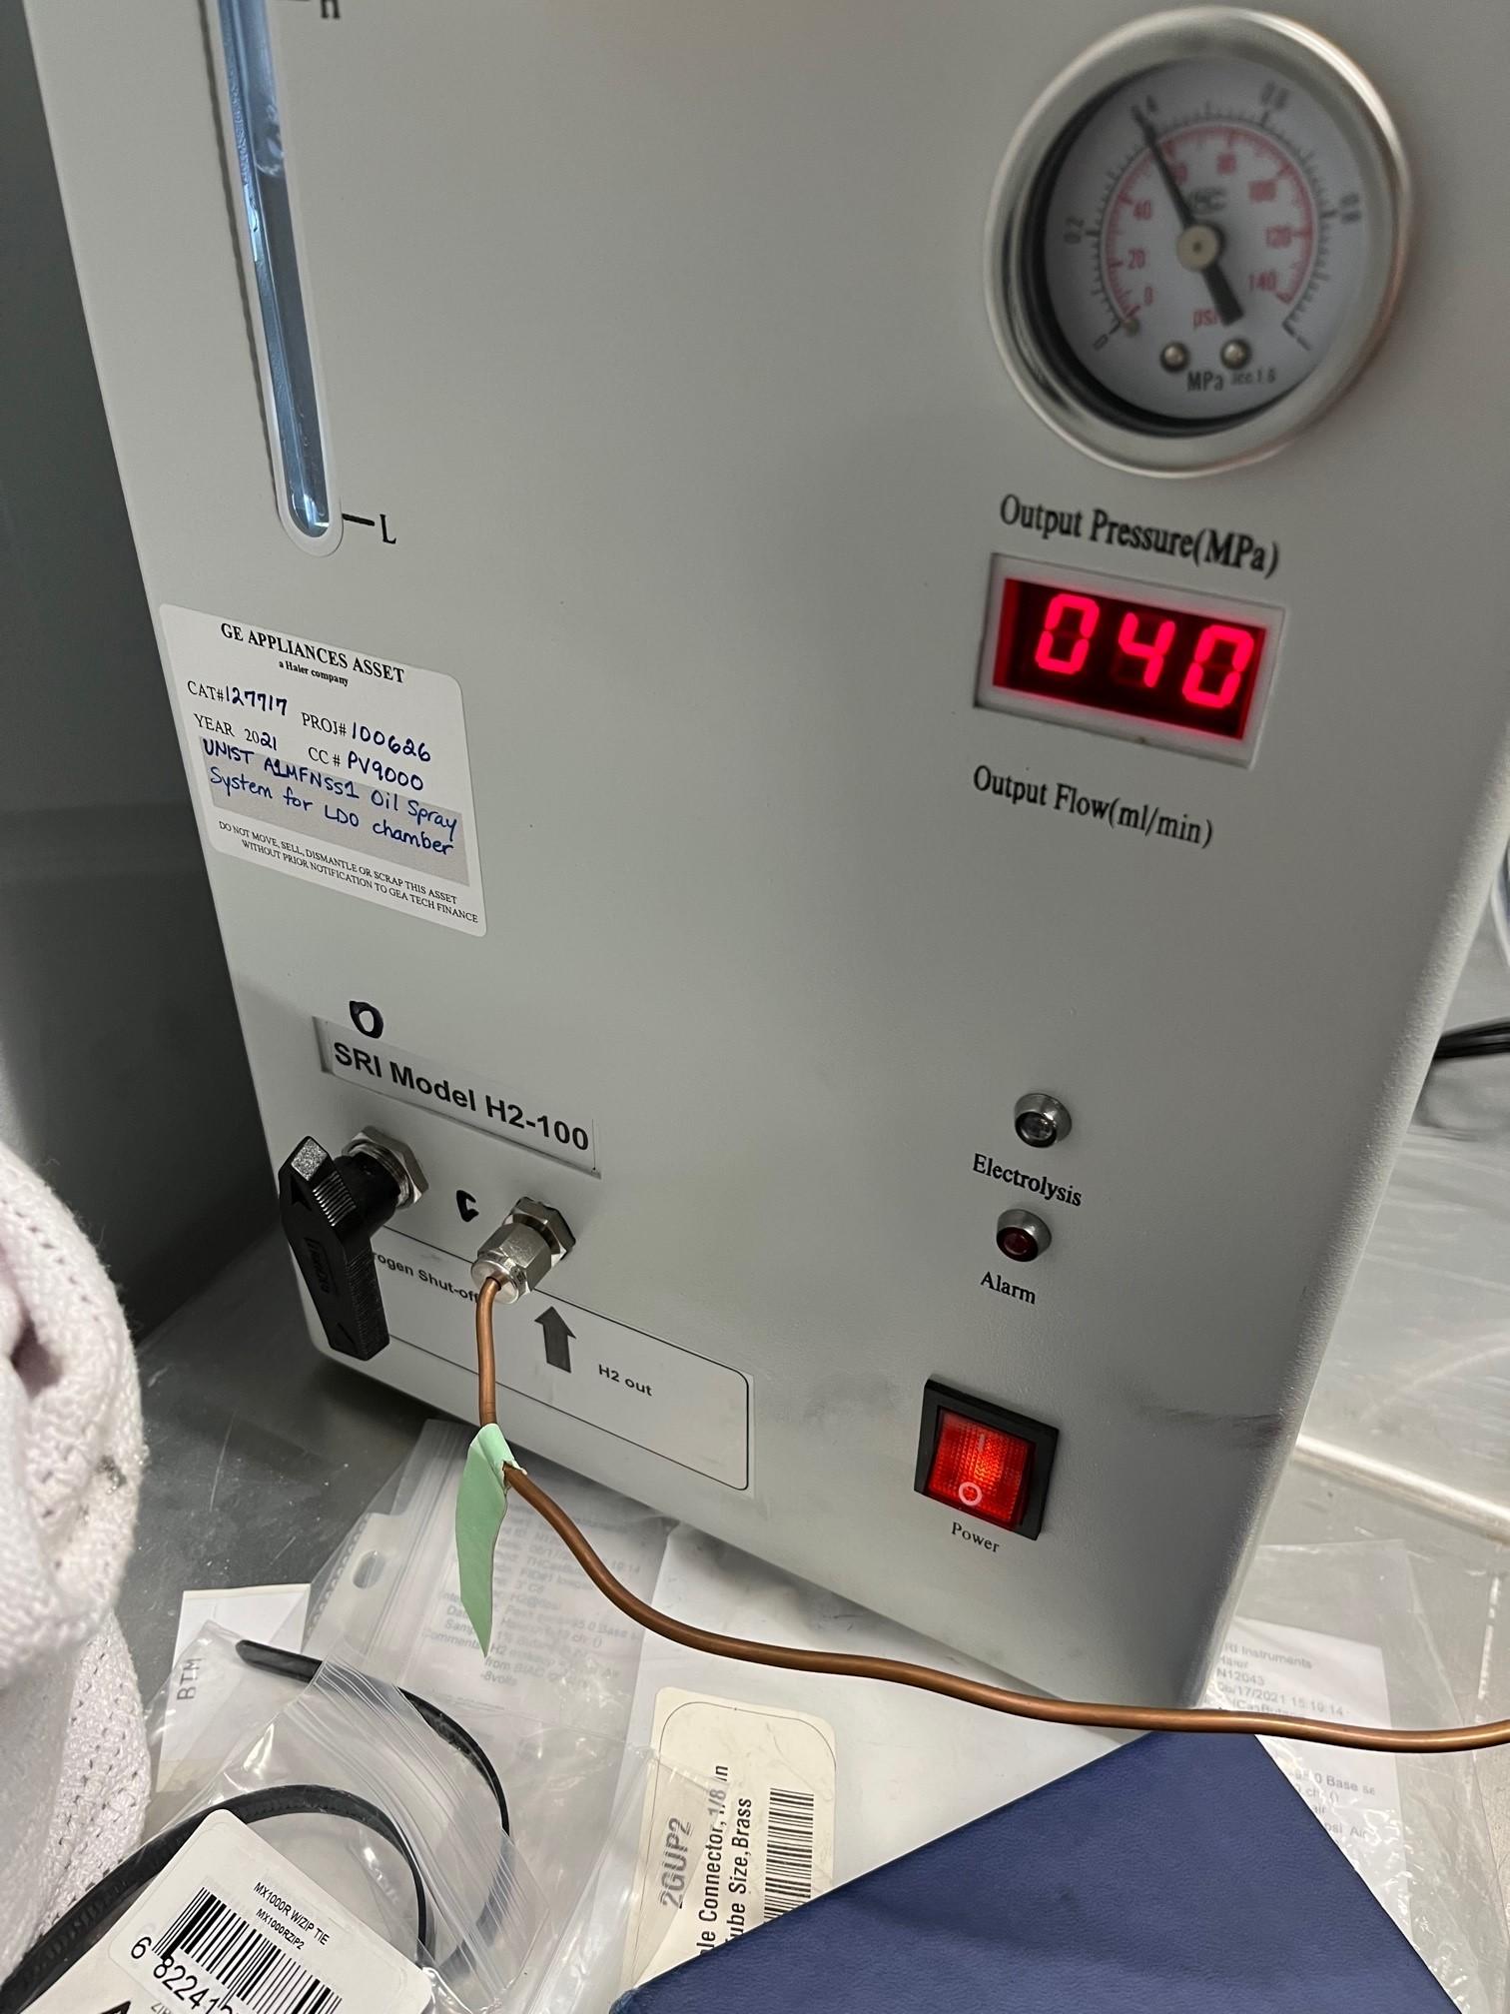Wait 20-25 minutes for the pressure to rise to ~60 psi (5A) and the flow rate to drop to 10 or 0 (5B). If after 20-25 minutes this hasn’t occurred, check that the valve is closed firmly (Step 3) and that the desiccant dryer cap is tightly closed (Step 2, image 2B). **You CANNOT proceed until the H2 generator is in this state**.

**5B**

**5A**

1. Open the H2 output valve on the SRI Model H2-100 Hydrogen Generator (3A). The flow rate will increase to around 80 (5B) indicating the H2 is flowing to the gas chromatograph.
2. Turn on power to the SRI8610C Gas Chromatograph (7A). 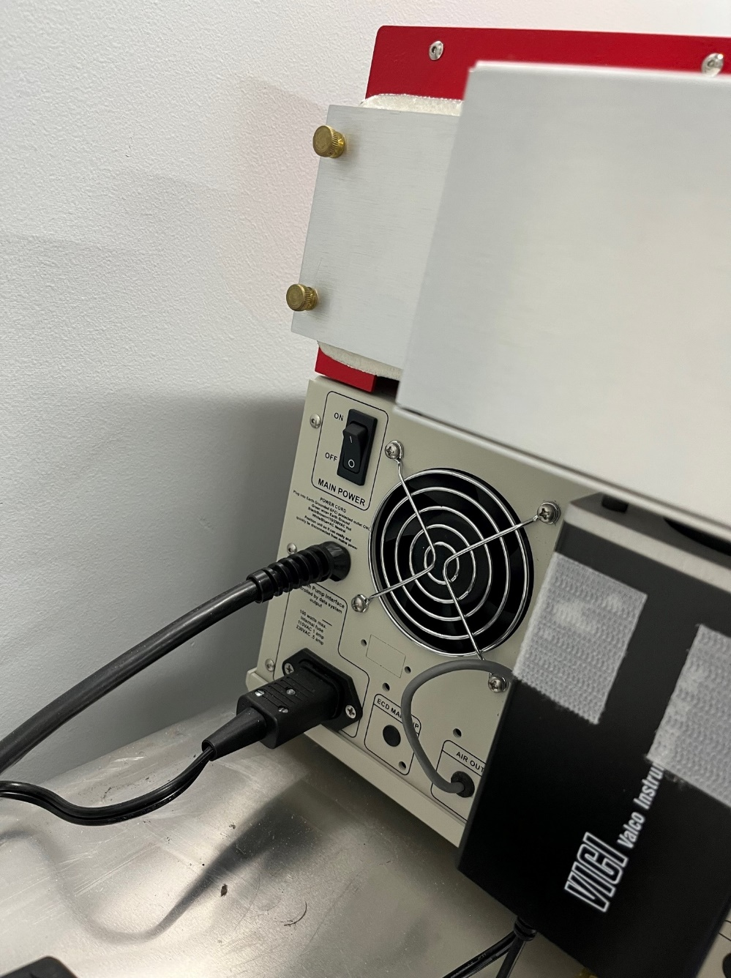

**7A**

1. Verify that the power for SRI8610C Gas Chromatograph Valve 4 is on (8A). The display should say “Pos A” or “Pos B”. If the screen is blank, verify power is plugged in (8B).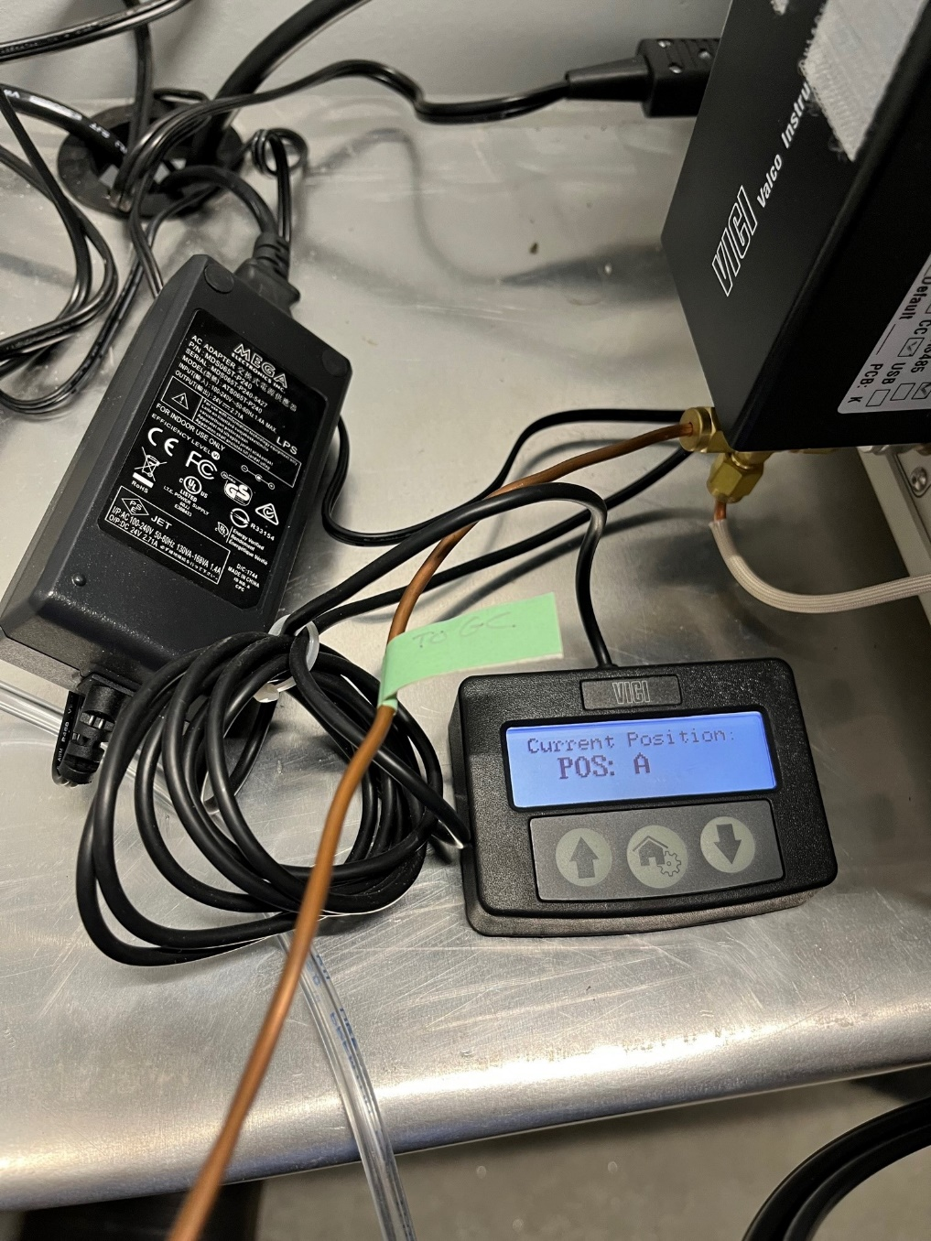

**8B**

**8A**

1. Start PeakSimple on the Test Computer.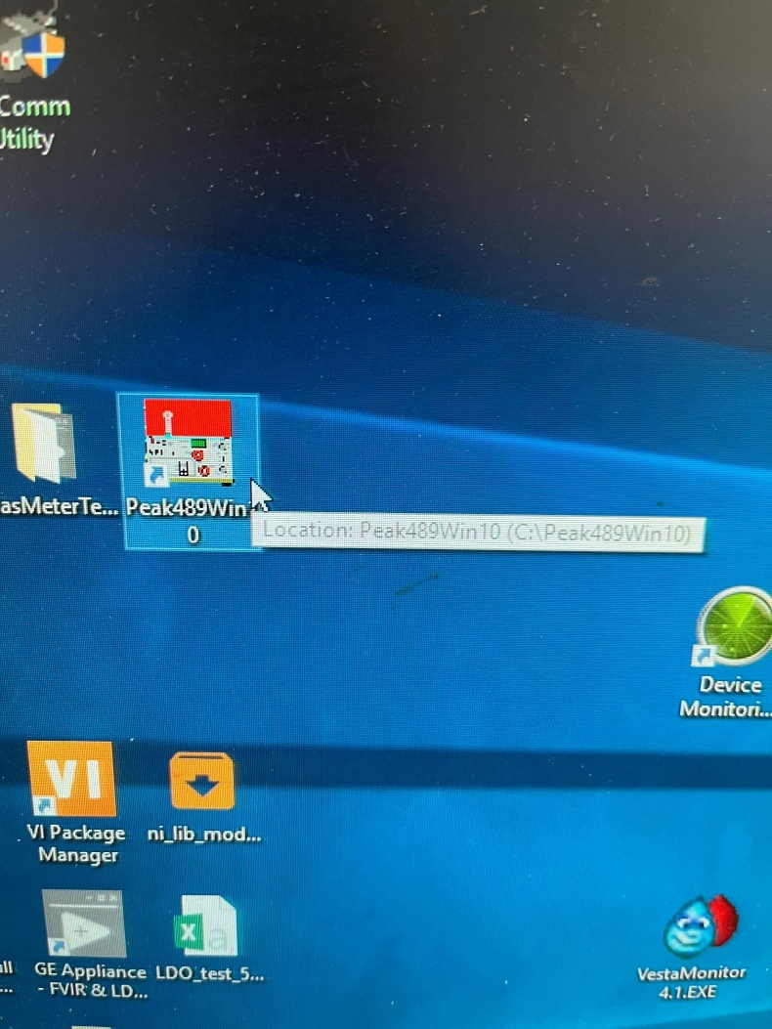
2. Once PeakSimple loads and connects to the Gas Chromatograph, verify the Post Run Conditions for Channels 1-4.
   1. Click the 1234 icon. 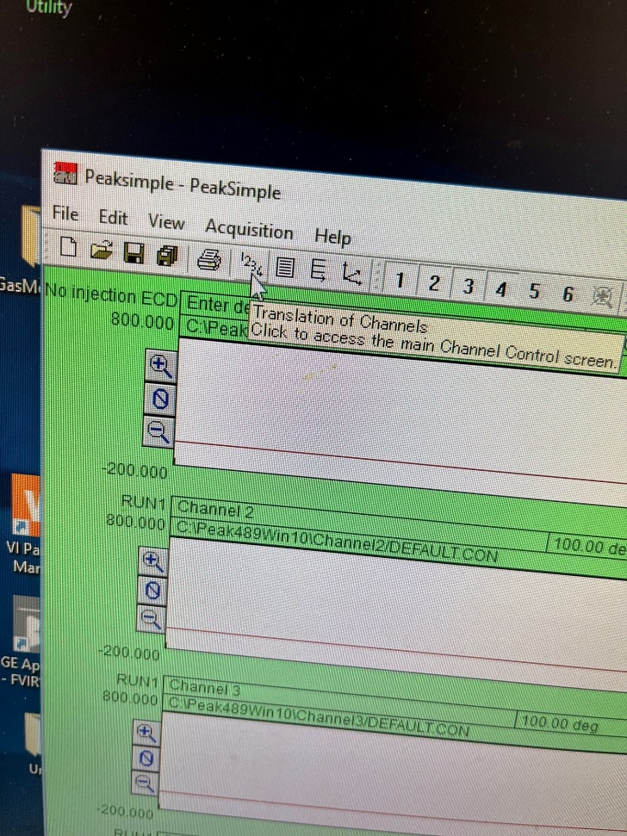
   2. Click Channel 1 -> PostRun 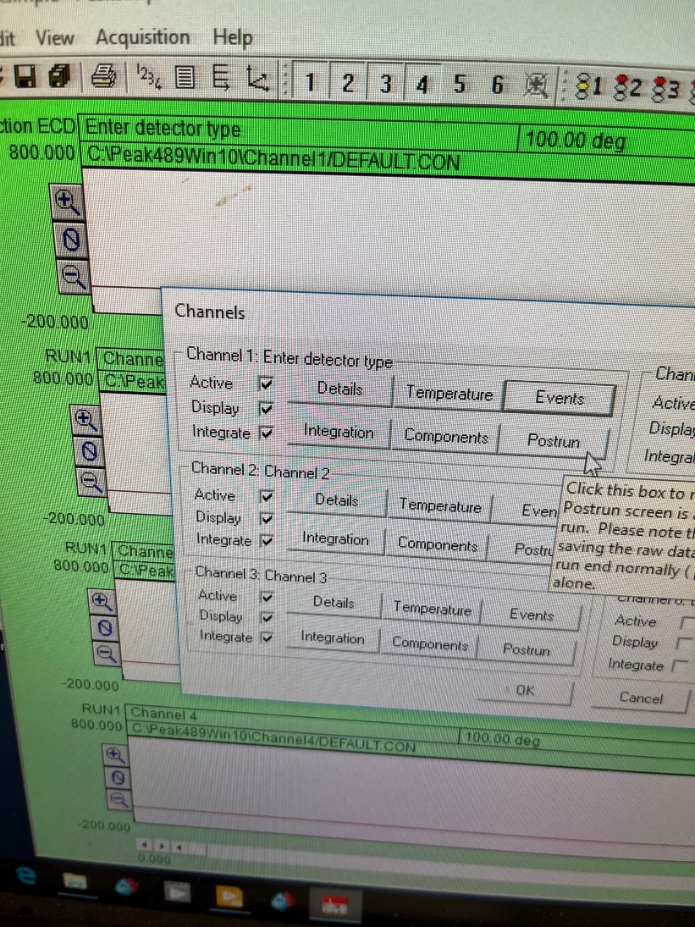
   3. 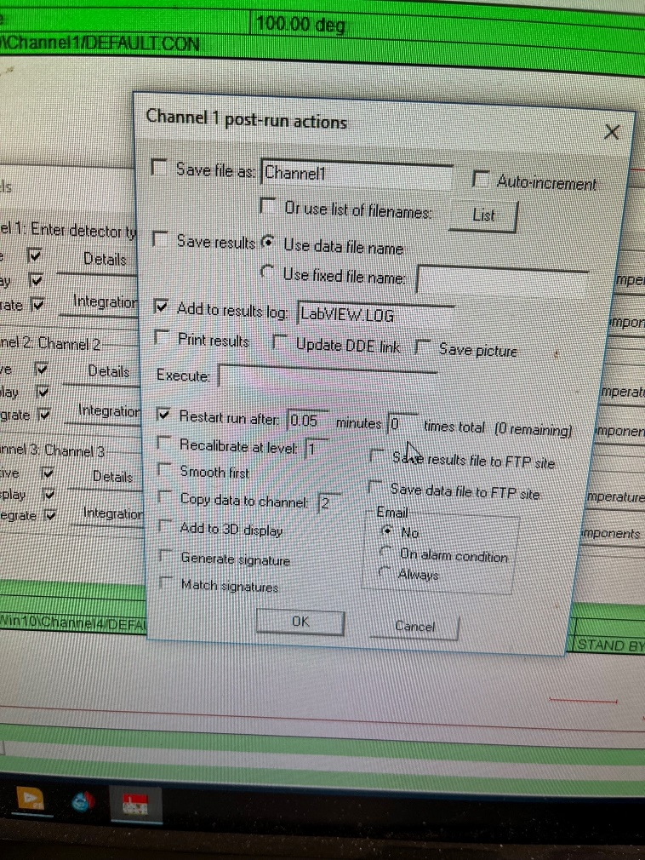Verify the Log is LabVIEW.log (10A) and Restart is 0.05 Minutes 0 times (0 (zero) means run until stopped) (10B)

**10B**

**10A**

* 1. Click OK, and open Postrun on Channels 2,3, and 4 and verify the Log is LabVIEW.log (10A). Restart (10B) should be **unchecked** on Channels 2,3, and 4.

1. Wait **30 minutes** for the SRI8610C Gas Chromatograph to reach temperature and stabilize. The start run button on the GC will glow green (indicating ready) before 30 minutes but starting early will lead to inaccurate readings.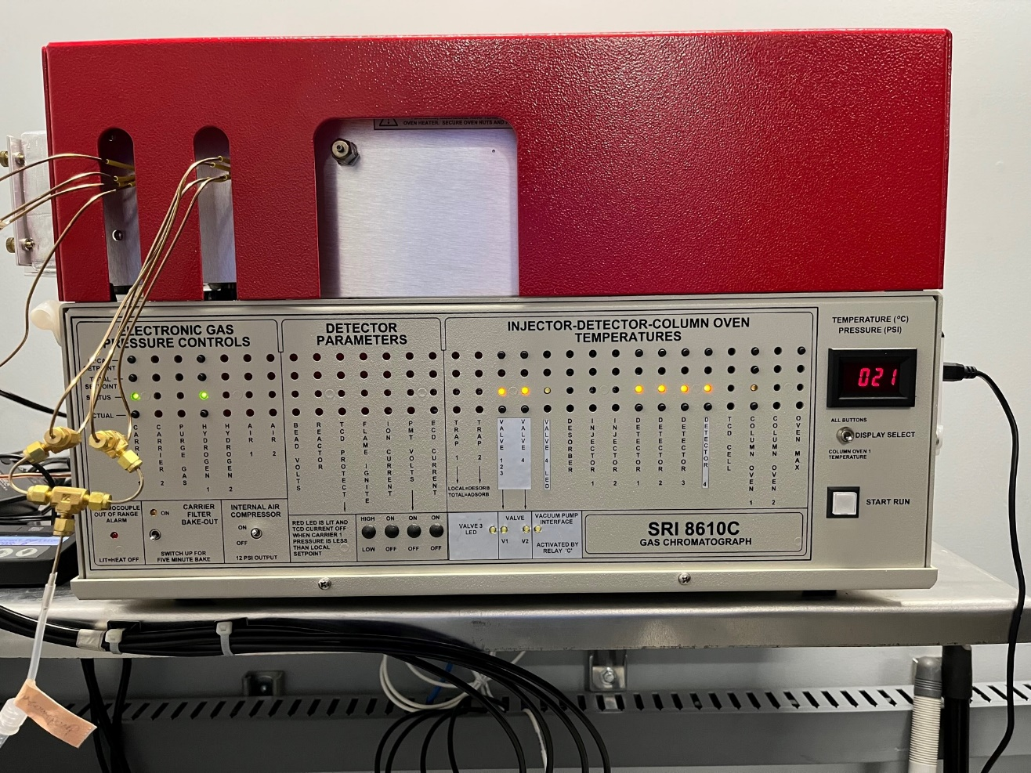
2. Letter

   Description automatically generated with low confidence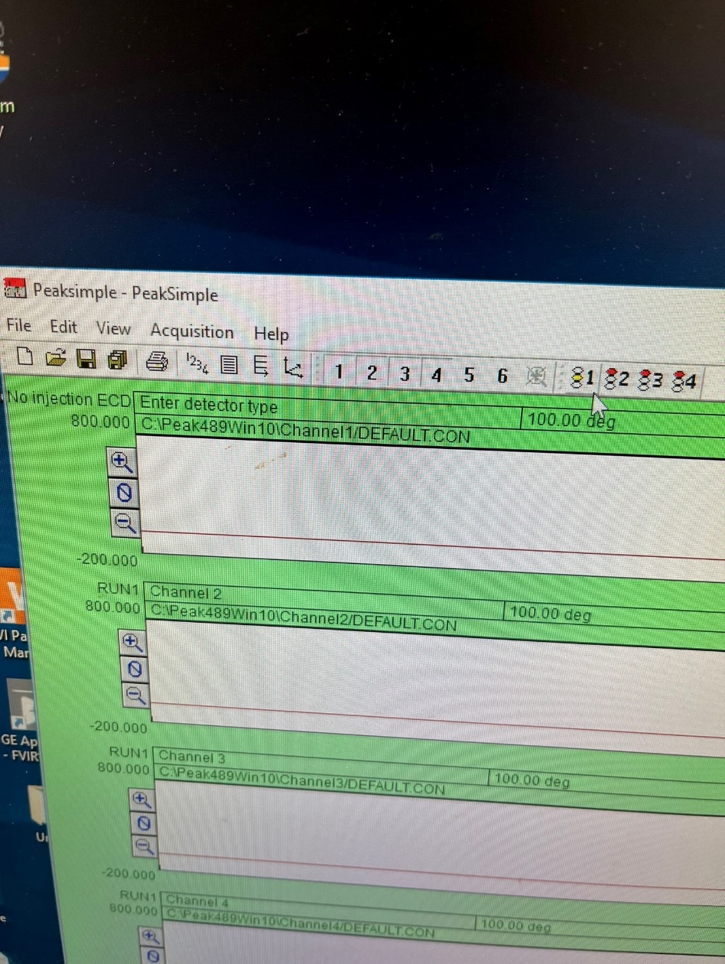Click the Run 1 button. It will change from the yellow middle indicator being active to the lower green one. You will also hear the GC operating, intermittently running the vacuum pump and operating valves.

**Running**

**Idle, not running**

1. 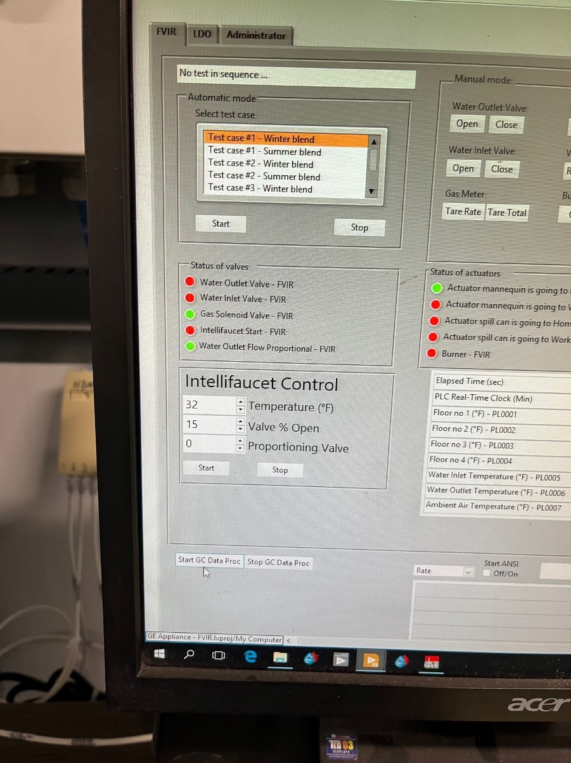From within LabVIEW, click “Start GC Data Proc” to start reading data output from the GC. It is updated once every minute.